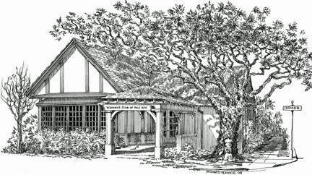

Financial Assistance Application
The Woman’s Club of Palo Alto

Financial assistance is available to those members seeking partial relief from our yearly dues as a result of financial hardship. Assistance is available to members who have discharged their duties to the Club.

If you are requesting assistance due to financial hardship, please complete the information below and include this form with your Membership Renewal Form. This information is confidential and will be authorized by the Membership and Financial Committee chairs.

****************************************************************************************

Financial Assistance Application

Date: __________________

- Name: _________________________________________

Members with financial assistance are asked to pay at least $175.

Adjusted Membership Dues $175

I can pay more +______

Total Adjusted Dues $______

If it is financially difficult for you to pay $175, please contact the Membership chair.

- Signature: ___________________________________________________________________

